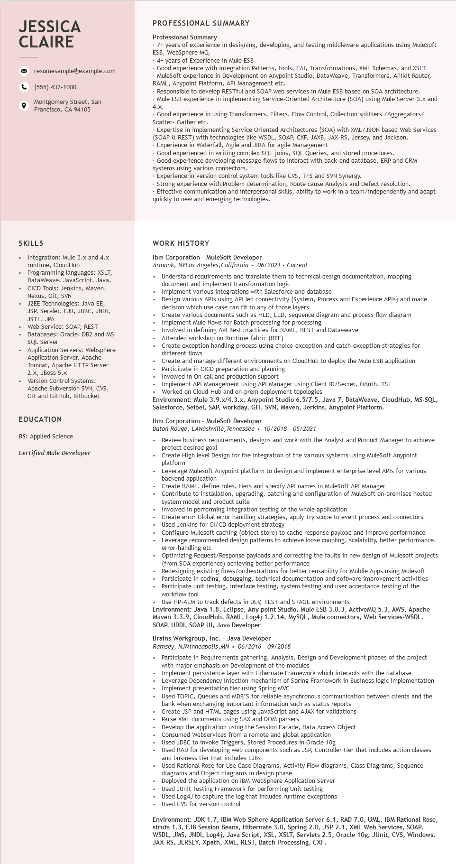
JESSICA CLAIRE
9
resumesample@example.com
(555) 432-1000
Montgomery Street, San Francisco, CA 94105
PROFESSIONAL SUMMARY
Professional Summary
7+ years of experience in designing, developing, and testing middleware applications using MuleSoft ESB, WebSphere MQ.
4+ years of Experience in Mule ESB
Good experience with integration Patterns, tools, EAI, Transformations, XML Schemas, and XSLT • MuleSoft experience in Development on Anypoint Studio, DataWeave, Transformers, APIkit Router, RAML, Anypoint Platform, API Management etc.
Responsible to develop RESTful and SOAP web services in Mule ESB based on SOA architecture. Mule ESB experience in implementing Service-Oriented Architecture (SOA) using Mule Server 3.x and
4.X.
Good experience in using Transformers, Filters, Flow Control, Collection splitters /Aggregators/ Scatter- Gather etc.
•Expertise in implementing Service Oriented Architectures (SOA) with XML/JSON based Web Services (SOAP & REST) with technologies like WSDL, SOAP, CXF, JAXB, JAX-RS, Jersey, and Jackson. Experience in Waterfall, Agile and JIRA for agile Management
Good experienced in writing complex SQL joins, SQL Queries, and stored procedures.
Good experience developing message flows to interact with back-end database, ERP and CRM
systems using various connectors.
• Experience in version control system tools like CVS, TFS and SVN Synergy.
• Strong experience with Problem determination, Route cause Analysis and Defect resolution.
• Effective communication and interpersonal skills, ability to work in a team/independently and adapt quickly to new and emerging technologies.
SKILLS
Integration: Mule 3.x and 4.x runtime, CloudHub Programming languages: XSLT, DataWeave, JavaScript, Java. CICD Tools: Jenkins, Maven, Nexus, Git, SVN
J2EE Technologies: Java EE, JSP, Servlet, EJB, JDBC, JNDI, JSTL,
JPA
Web Service: SOAP, REST
Databases: Oracle, DB2 and MS SQL Server
Application Servers: Websphere Application Server, Apache Tom Tomcat, Apache HTTP Server 2.X, JBoss 5.x
Version Control Systems:
Apache Subversion SVN, CVS, Git and GitHub, Bitbucket
EDUCATION
BS: Applied Science
Certified Mule Developer
WORK HISTORY
Ibm Corporation - MuleSoft Developer
Armonk, NYLos Angeles, California. 06/2021 - Current
Understand requirements and translate them to technical design documentation, mapping document and implement transformation logic
Implement various integrations with Salesforce and database
Design various APIs using API led connectivity (System, Process and Experience APIs) and made decision which use case can fit to any of those layers
Create various documents such as HLD, LLD, sequence diagram and process flow diagram Implement Mule flows for Batch processing for processing
Involved in defining API Best practices for RAML, REST and Dataweave
Attended workshop on Runtime fabric (RTF)
Create exception handling process using choice-exception and catch-exception strategies for different flows
Create and manage different environments on CloudHub to deploy the Mule ESB application Participate in in CICD preparation and planning
Involved in On-call and production support
• Implement API Management using API Manager using Client ID/Secret, OAuth, TSL
Worked on Cloud-Hub and on-prem deployment topologies
Environment: Mule 3.9.x/4.3.x, Anypoint Studio 6.5/7.5, Java 7, DataWeave, CloudHub, MS-SQL, Salesforce, Seibel, SAP, workday, GIT, SVN, Maven, Jerkins, Anypoint Platform.
Ibm Corporation - MuleSoft Developer
Baton Rouge, LANashville, Tennessee. 10/2018 - 05/2021
Review business requirements, designs and work with the Analyst and Product Manager to achieve project desired goal
Create High level Design for the integration of the various systems using MuleSoft Anypoint platform
Leverage Mulesoft Anypoint platform to design and implement enterprise level APIs for various backend application
Create RAML, define roles, tiers and specify API names in MuleSoft API Manager
Contribute to installation, upgrading, patching and configuration of MuleSoft on-premises hosted system model and product suite
Involved in performing Integration testing of the whole application
Create error Global error handling strategies, apply Try scope to event process and connectors Used Jenkins for CI/CD deployment strategy
Configure Mulesoft caching (object store) to cache response payload and improve performance Leverage recommended design patterns to achieve loose coupling, scalability, better performance, error-handling etc
Optimizing Request/Response payloads and correcting the faults in new design of Mulesoft projects (from SOA experience) achieving better performance
Redesigning existing flows/orchestrations for better reusability for Mobile Apps using Mulesoft Participate in coding, debugging, technical documentation and software improvement activities Participate unit testing, interface testing, system testing and user acceptance testing of the workflow tool
Use HP-ALM to track defects in DEV, TEST and STAGE environments
Environment: Java 1.8, Eclipse, Any point Studio, Mule ESB 3.8.3, ActiveMQ 5.3, AWS, Apache- Maven 3.3.9, CloudHub, RAML, Log4j 1.2.14, MySQL, Mule connectors, Web Services-WSDL, SOAP, UDDI, SOAP UI, Java Developer
Brains Workgroup, Inc. - Java Developer
Ramsey, NJMinneapolis, MN 06/2016 - 09/2018
• Participate in Requirements gathering, Analysis, Design and Development phases of the project with major emphasis on Development of the modules
Implement persistence layer with Hibernate Framework which interacts with the database
• Leverage Dependency Injection mechanism of Spring Framework in Business logic implementation • Implement presentation tier using Spring MVC
Used TOPIC, Queues and MDB'S for reliable asynchronous communication between clients and the bank when exchanging important information such as status reports Create JSP and HTML pages using JavaScript and AJAX for validations
Parse XML documents using SAX and DOM parsers
Develop the application using the Session Facade, Data Access Object
Consumed Webservices from a remote and global application
consumed
euservic
Used JDBC to invoke Triggers, Stored Procedures in Oracle 10g
Used RAD for developing web components such as JSP, Controller tier that includes action classes and business tier that includes EJBS
and busi
Used Rational Rose for Use Case Diagrams, Activity Flow diagrams, Class Diagrams, Sequence diagrams and Object diagrams in design phase
Deployed the application on IBM WebSphere Application Server
Used JUnit Testing Framework for performing Unit testing Used Log4J to capture the log that includes runtime exceptions Used CVS for version control
Environment: JDK 1.7, IBM Web Sphere Application Server 6.1, RAD 7.0, UML, IBM Rational Rose, struts 1.3, EJB Session Beans, Hibernate 3.0, Spring 2.0, JSP 2.1, XML Web Services, SOAP, WSDL, JMS, JNDI, Log4j, Java Script, XSL, XSLT, Servlets 2.5, Oracle 10g, JUnit, CVS, Windows. JAX-RS, JERSEY, Xpath, XML, REST, Batch Processing, CXF.

